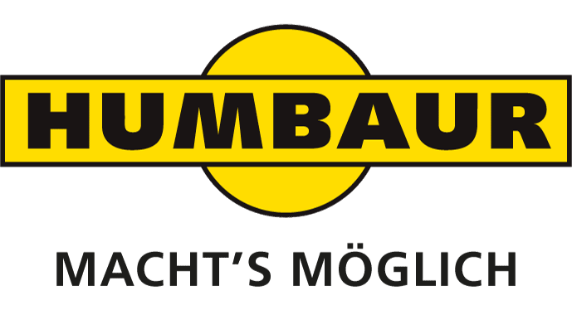
HUMBAUR SHOWS 5-AXLE FLATBED SEMI-TRAILER HTS 40K AT IAA COMMERCIAL VEHICLE FAIR 2018
Monika Niederreiner
Head of Corporate
Communication

Humbaur GmbH
Mercedesring 1
86368 Gersthofen
Germany

Phone +49 821 24929-532
Fax +49 821 24929-500
m.niederreiner@humbaur.com
www.humbaur.com

Gersthofen, 17. September 2018

Gersthofen, September 19, 2018

A strong helper celebrates its premiere: The newly developed Humbaur HTS 40K semitrailer flatbed semitrailer can be seen at the IAA Commercial Vehicles from 20 to 27 September 2018. It features a particularly low flatbed, two trailing steering axles and other practical details for transporting heavy goods.

The flatbed semi-trailer HTS 40K has been redesigned from the ground up. Its outstanding features include the very low loading height of 790 mm, optimum corrosion protection thanks to its fully hot-dip galvanised chassis and its generous equipment provision including tie-down points.
The HTS 40K is equipped with a five-axle air-suspended flatbed chassis with ECAS electronically controlled air suspension. ECAS allows the chassis' air suspension system to be dynamically controlled based on sensor data and the axle load to be monitored from the driver's cab. The five axles are composed of two trailing steering axles and three lift axles (two circuits). An EBS braking system in a 4S/3M configuration ensures safe driving; spring-loaded parking brakes are applied to axles 1, 2 and 3 when stationary. Three chassis levels are defined ex works: The flatbed is lowered onto support feet when loading and unloading to achieve optimal stability. In addition to the standard chassis height, there is also an off-road chassis height with additional ground clearance to protect the chassis and important parts of the trailer on uneven ground.
Axles 1, 2 and 4 are raised for unladen journeys; axle 1 is raised for partial loads with aggregate loads of up to 30 t; all axles are lowered for aggregate loads of more than 30 t. To help move off, axle 1 can be raised at speeds of up to 30 km/h via a button in the towing vehicle (PIN 12) so as to put more pressure on the drive axles.
The Humbaur HTS 40K features a solid welded construction made of high-strength fine-grained steel; full-width crossbars ensure the highest level of stability. The rear offset along with the climbing aids provide a shallow ramp angle and thereby additional safety during loading and unloading. The single-section, hot-dip galvanised ramps can be laterally adjusted and are equipped with a direct-acting spring lifting mechanism for easier operation. They are reliably secured using a turnbuckle and counter stop.
There are an ample number of tie-down points to secure cargo: 3 pairs of lashing rings with 6 t tensile force are recessed in the bridge floor, 3 pairs of tie-down points with 3 t tensile force in the bridge floor exterior. 7 pairs of lashing rings with 10 t tensile force are recessed in the trailer floor, 1 pair of tie-down points with 3 t tensile force in the outer frame of the trailer floor. 10 pair of tie-down points with 2 t tensile force are located in the wheel arches on the outer frame, there are also 6 pairs of stanchion recesses with 3 t retaining force for plug-in stanchions (90 x 50 mm).
The maximum permissible total weight is 52 t, with an indivisible load 58 t; the technical total weight is 60 t, the technical axle load is 40 t. In its basic configuration, the unladen weight of the HTS 40K is 10.5 t. The trailer floor measures 9.13 x 2.54 m, the bridge floor 3.50 x 2.54 m. The 20-wheeled flatbed has slewing radius of 1.98 m with a two-axle towing vehicle, 2.32 m with a three-axle towing vehicle. The front overhang radius is 1.7 m for a two-axle towing vehicle, 1.5 m on a three-axle towing vehicle.

Service: Humbaur 24/7

Since July, the breakdown service Humbaur 24/7 has been available in Germany for the manufacturer's flatbed trailers and for all FlexBox vehicles - regardless of the manufacturer of the chassis. At the IAA Commercial Vehicles 2018 the service will start internationally. Humbaur is the first commercial vehicle manufacturer to work together with ADAC Truckservice to create a joint service network of over 1200 workshops in Germany and around 40000 workshops throughout Europe.

Humbaur 24/7 provides assistance for any kind of breakdown. For lift platforms, cooling units and the vehicle, access to the respective manufacturer service is also possible. A service customer card contains all important information and questions that you should answer on the hotline in the event of service: for example, chassis number, registration number, problem/defect and other information.

You too can be a follower!

HUMBAUR is one of the largest suppliers of trailers and vehicle bodies in the world. The owner-managed family company offers around 420 different series models for commercial and private clients and 230 models of its FlexBox box bodies. With 500 employees, around 52,000 trailers are produced at the Gersthofen site per annum—all of which are "Made in Germany". The expert for trailers and transport solutions from 750-kg to 50-t maximum weight is active nationally and internationally and also manufactures special solutions. Over 500 dealers in Germany and 26 other European countries offer local expertise.
Visit us at: www.humbaur.com

