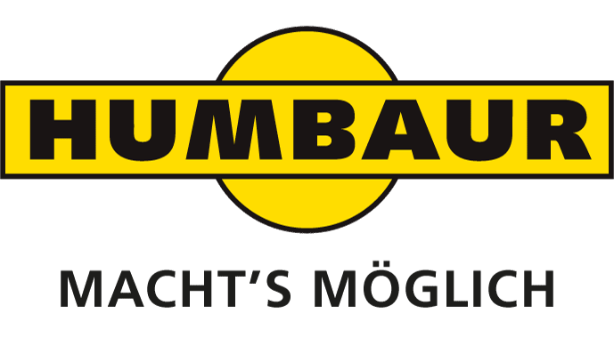
HUMBAUR HTK 19 now also available with Bordmatic
Monika Niederreiner
Head of Corporate
Communication

Humbaur GmbH
Mercedesring 1
86368 Gersthofen
Germany

Phone +49 821 24929-532
Fax +49 821 24929-500
m.niederreiner@humbaur.com
www.humbaur.com

Gersthofen, 17. September 2018

Gersthofen, September 19, 2018

At the IAA Commercial Vehicles exhibition 2018, HUMBAUR—one of the largest manufacturers of trailers and vehicle bodies in Europe—is presenting a new feature for its three-way tipper HTK 19: the tipper trailer is now also available with bordmatic.

Humbaur has further improved the HTK 19—this all-rounder in its range of three-side tippers can now be optionally equipped with bordmatic. The hydraulically opening sideboard significantly shortens the tipping procedure because it no longer requires someone to get out especially. Another advantage is that the inclined sideboard acts as a chute and directs the bulk material away from the vehicle. Hardly any of the cargo falls in front of or behind the axle; an accumulation of such deposits can make it difficult for the vehicle to move off again.
The HTK 19 t does not only transport bulk materials such as gravel, earth, sand or concrete, it can also accommodate pallets. The professional construction trailer is designed so that two Euro pallets can easily be loaded next to each other. As a result there are no obstructions to the safe transport of palletised bricks or other building materials, for example. This makes the trailer an indispensable companion for heavy-duty applications. Due to the payload-optimised design and the resulting low tare weight, payloads of up to 15 tonnes are possible.
The tandem three-way tipper is robust and is designed for a variety of applications. It also features optimal driving and tipping characteristics. Air suspension allows the loading height to be lowered. The perfectly attuned materials used to construct the trailer are also an impressive feature. Top-quality wear resistance is offered by the combination of Hardox sideboards and a Hardox floor. The HTK 19 t can alternatively be ordered as a painted version or with a galvanised bridge and a S400 steel floor.

You too can be a follower!

HUMBAUR is one of the largest suppliers of trailers and vehicle bodies in the world. The owner-managed family company offers around 420 different series models for commercial and private clients and 230 models of its FlexBox box bodies. With 500 employees, around 52,000 trailers are produced at the Gersthofen site per annum—all of which are "Made in Germany". The expert for trailers and transport solutions from 750-kg to 50-t maximum weight is active nationally and internationally and also manufactures special solutions. Over 500 dealers in Germany and 26 other European countries offer local expertise.
Visit us at: www.humbaur.com

